Your Help is Needed!

The club needs help at up and coming home matches at Sutcliffe Park.

Do you or your children take part in any of the competitions we organise at Sutcliffe Park Track?

Can you lend us some time/help to keep these meetings running successfully?

What is required?:
On day of the meeting –
9am - 2 or 3 people to help set up, ready for the meeting to start at 11.30 or 12 noon. (The tasks involve making sure the correct equipment is at each track and field event site, in good working order. Full training will be given.)

11:30am/12 noon - An EDM operator for home matches. (EDM is the piece of kit that saves us using tape measures on the throwing events, making for a much smoother competition.)
This is not a difficult job, but important for keeping the events moving. A technically able person can pick it up very quickly.

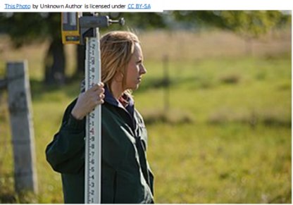

As a club we have a small team of officials for each meeting. In some leagues there are points available for officials.
If you would like to become an official, please contact Barry Ferguson - barrington@barryferg.plus.com

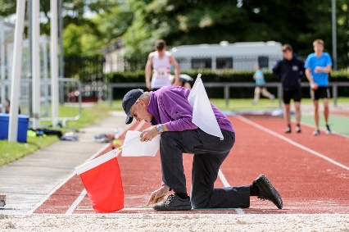

Dates of Home matches this season:
Day
Day | Date | Event
Saturday | 9th April | Club Trials
Sunday | 24th April | YDL Upper Age Group
Sunday | 8th May | YDL Lower Age Group
Sunday | 22nd May | Southern Athletic League
Saturday | 16th July | Southern Athletic League

Evening – 6:30pm
Day | Date | Event
Monday | 9th May | SCVAC
Wednesday | 25th May | BMC/Cambridge Open
Wednesday | 22nd June | BMC/Cambridge Open
Wednesday | 20th July | BMC/Cambridge Open
Wednesday | 17th August | BMC/Cambridge Open

Please seriously consider volunteering your time and joining our team to help your club!

If you are able to help, please contact:
Chris Head-Rapson – chrisheadrapson@gmail.com

